COSC301 – Assignment 1 - Reuben Sweetman-Gough
IPV4
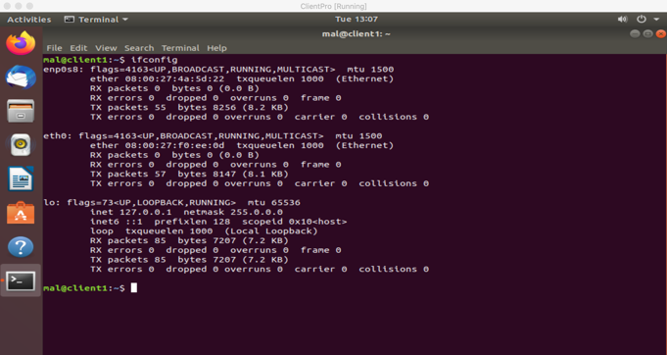 | Ifconfig showing networks for Client Pro
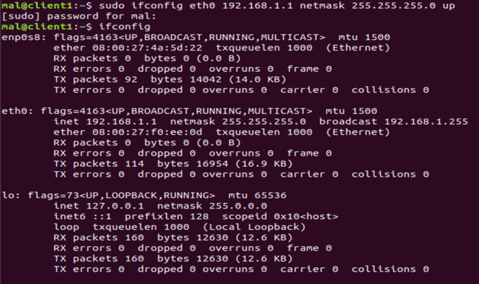 | Setting the ip for eth0
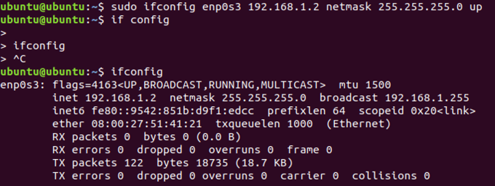 | Ip address for client2
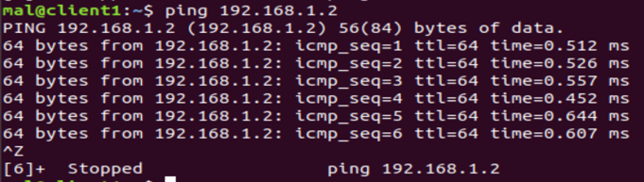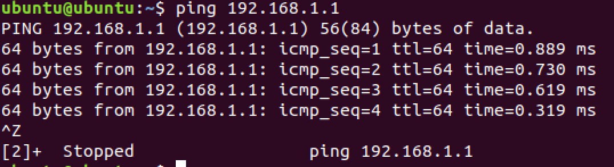 | Pinging client 2 from client pro  Pinging client pro from client 2
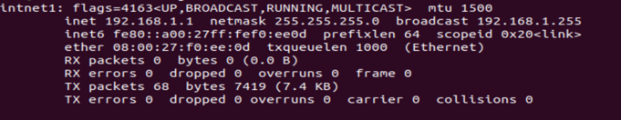 | Changed 70-intnet1.link and 70-intnet1.link to change names of eth0 and enp0s8  And added auto address to them from /etc/network/interfaces

IPV6
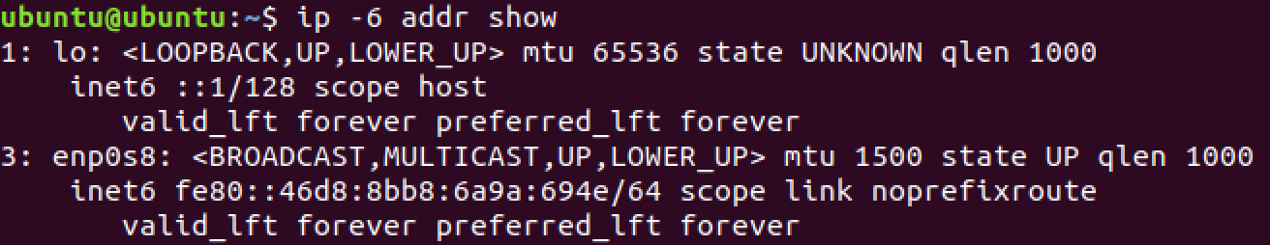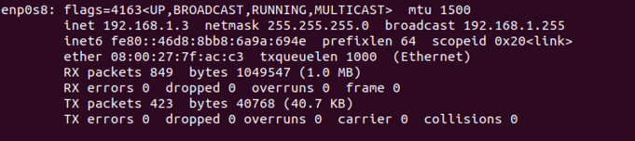 | Client 2 ipv6 address
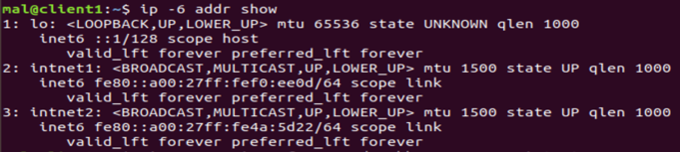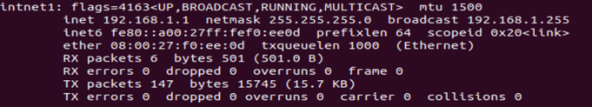 | Show ClientPro ipv6 address
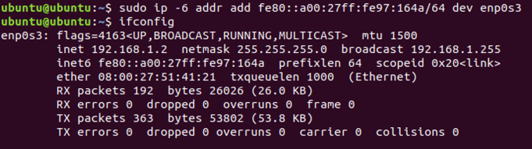 | Added ipv6 in client2 to enp0s3
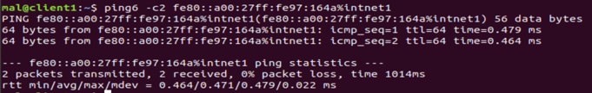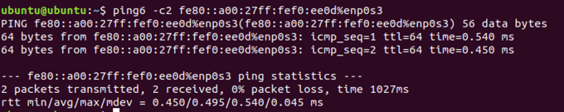 | Pings ipv6 on both clients

